Name: Andrew Hwang
ID: A11570188
LOGIN: cs12sda
HW1-Answers
Problem 1
A. 1) javadoc Counter.java
2) javadoc -author -version Counter.java

B. 1) java -cp ‘.:/usr/share/java/*’ junit.textui.TestRunner CounterTest
2) A permenant change to specify the classpath can manually be done through control panel.
The user will go to the advanced tab of the system settings through the control panel. From there the user can click on Environment Variables which is under System Variables and edit the path environment variable.
C. 1)
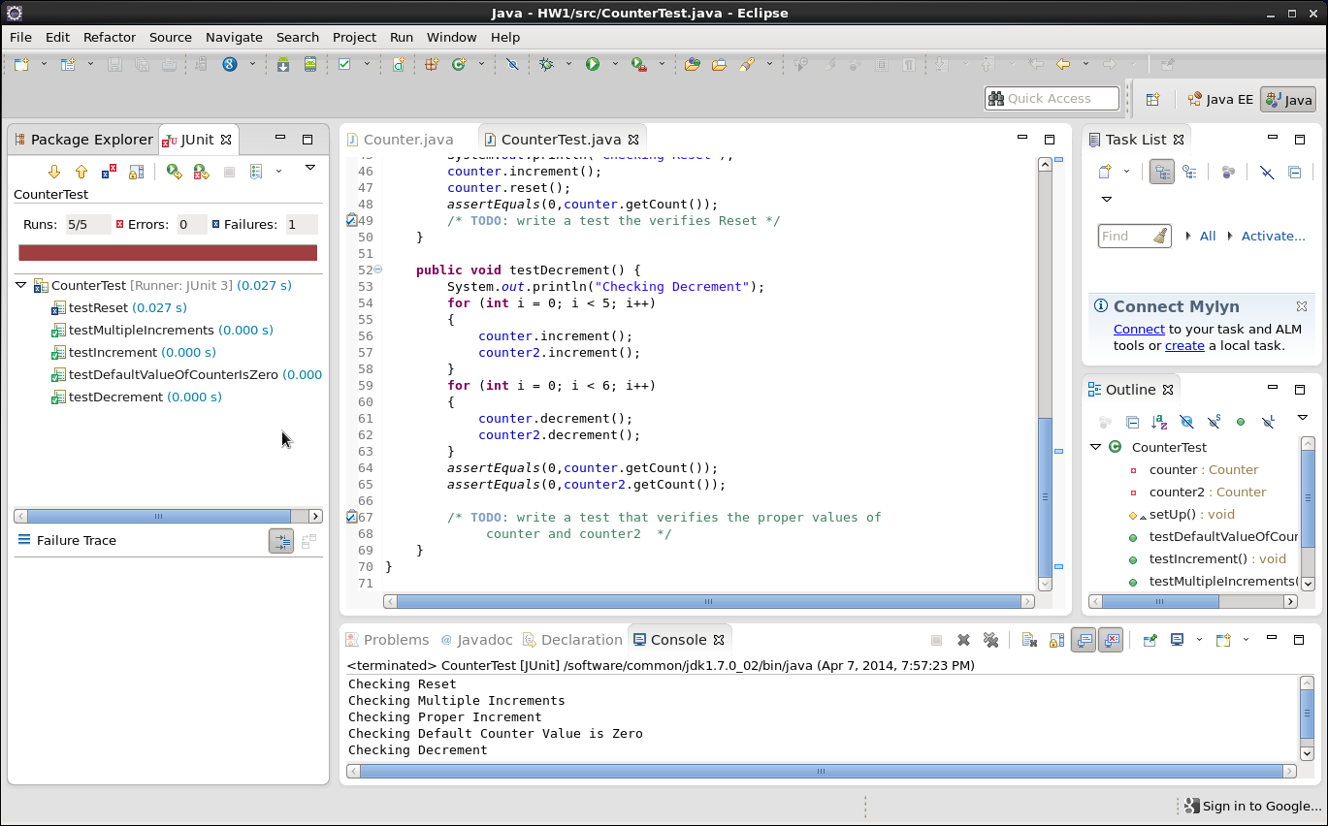
2) To add a classpath in Eclipse go to the Eclipse Project Properties window and click on Java Build Path and choose the Libraries tab. To add the jar file click on Add External JARs.

